|  |  |  |
| --- | --- | --- |
| Catalog of products | SIM card connector |  |
| Card connection mode | Self firing type |  |
| Card type | NanoSIM card |  |
| Connector Type | Seat of cards |  |
| Maximum height of the ontology | 1.25mm |  |
| Contact material | Copper alloy |  |
| Contact coating | Plating of gold |  |
| Operating temperature range | -40℃~+85℃ |  |
| Welding temperature (Max) | 260℃ |  |

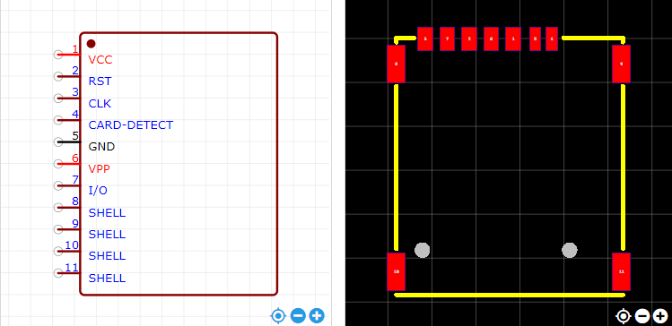

<https://item.szlcsc.com/353303.html>